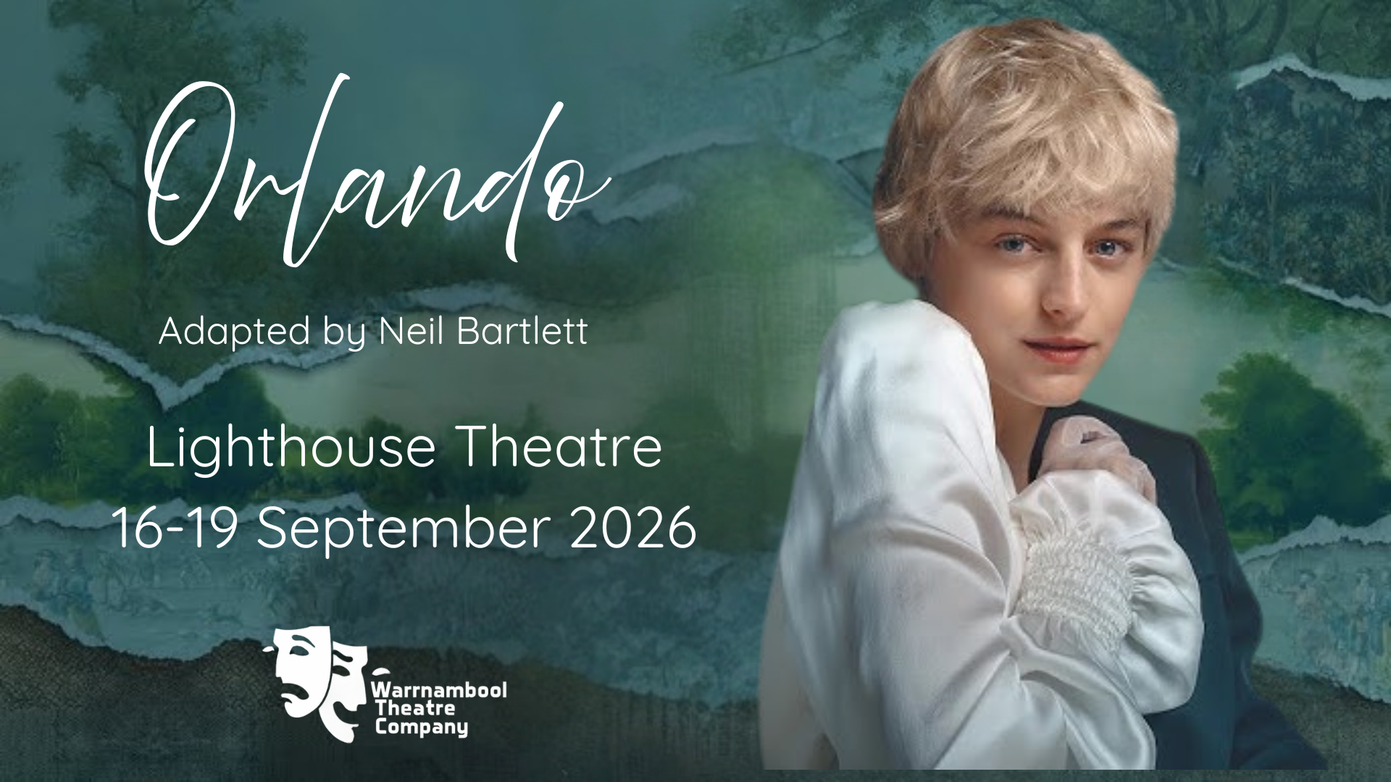

INFORMATION PACK

WARRNAMBOOL THEATRE COMPANY ETHOS

Warrnambool Theatre Company is proud to present Orlando. WTC strives to be an inclusive, welcoming, and collaborative organisation that provides opportunities for individuals to experience the thrill of the theatre. Mounting a successful production requires commitment, passion and collaboration from many individuals over several months. WTC believes that a production is above all a team experience; through working in a considerate, supportive and dedicated manner Orlando will be both a creative and critical success.

The following principles from the WTC Charter:

- All decisions made in the show will be made through the lens of inclusivity.
- Communication between all participants, both on and off the stage, will be respectful, honest, and open.
- An environment that meets the standards of child safety will be developed and enforced.
- Preference will be given to local performers, musicians, and theatre specialists from the southwest region to promote community engagement.
- A safe and non-discriminatory environment will be developed to allow all participants to give their best effort.
- Auditions will be conducted in a transparent process that allows participants to feel secure, valued and understood.

KEY CONTACTS

Producers: Penny McLeod & Dean Field
Director: Warren Easley
Assistant Directors: Ruby Shepherd, Sharon Gore & Paul Fimmel

PERFORMANCE DATES

Performance #1: Wed 16 Sept
Performance #2: Thursday 17 Sept
Performance #3: Friday 18 Sept
Performance #4: Sat 19 Sept (matinee)
Performance #5: Sat 19 Sep (evening)

SYNOPSIS
Orlando by Virginia Woolf
Adapted for the stage by Neil Bartlett

“How queer to have so many selves” (Virginia Woolf, 1935)

“It has to be half laughing, half serious, with great splashes of exaggeration” (Virginia Woolf, 1927)

Both of these phrases have been taken from Neil Bartlett's introduction to his adaptation and will form our fundamental approach to the WTC production.

Orlando is a journey of love, identity, and transformation.

Beginning as a young courtier in the time of Elizabeth I, Orlando moves across five centuries of history, through wars, revolutions, and social upheaval, even changing gender along the way. It is a life that refuses to be confined to one body, one era, or one definition. Across centuries of living and loving, Orlando ultimately finds the courage to truly be herself.

In Neil Bartlett’s sparkling stage adaptation, Woolf’s story takes on powerful contemporary resonance, celebrating the right to love and to be oneself beyond old orders and expectations. Bold, playful, and deeply human, Orlando asks a timeless question: who are we, when “nothing is any longer just one thing?”

FEES and MEMBERSHIP
There is a one-off participation fee of $60 to participate as a cast member in Orlando. This covers costs such as scripts, costumes, refreshments and other production costs.
Additionally, all cast members must be members of WTC. Annual WTC membership is $40 full fee or $30 concession (year ending Dec 2026). Apply for WTC membership via the WTC website, or click here.
Membership to WTC and participation fee can be paid at the same time.
Please let us know if these fees present a barrier to your participation — we can support you to make involvement possible.

REHEARSALS
Cast rehearsals will likely be held on Wednesday evenings and Sunday afternoons at TOAD Hall, corner Manifold and Princess Street Warrnambool.
Upon cast finalisation a comprehensive rehearsal schedule will be provided. Cast may not be required for all sessions but will be allocated specific times, where attendance is required.
Attendance Expectations:

- By accepting a role in this production, you are committing to rehearsals as scheduled.
- Any absences that you are already aware of (e.g. a booked holiday) should be listed on your audition form.
- Please support the production team and your fellow cast members by advising the directorial team of your absence as soon as possible.
- All cast must be available for production week, technical and dress rehearsals

AUDITIONS
Auditions will be held at TOAD Hall on the following dates:

27/2/26 | 6.30 - 8.30pm | Orlando & Mrs G
1/3/26 | 2 - 4pm | Orlando & Mrs G

13/3/26 | 6.30 - 8.30pm | ‘The Virginias’
15/3/26 | 2 - 4pm | ‘The Virginias’

The audition booking system will be made available at the information session.

AUDITION STRUCTURE
Initially we invite everyone to audition for Orlando or Mrs G, and those unsuccessful for those roles are strongly encouraged to audition for a Virginia role.
Orlando and Mrs G
Orlando’s audition comprises the opening Soliloquy as well as the closing one. Please consider how you approach the delivery of these two readings given the journey Orlando has undertaken.
Mrs Grimsditch reading is the start of Act 2 when Orlando returns to England in a woman's body and at a time far distant from when he had a man's one. Please consider the relationship between Mrs G and Orlando along with her relationship with the audience.
We aim to audition Orlando and Mrs G together in pairs i.e. first audition time with two Orlando’s and two Mrs G’s, second audition the same. Each audition will be approximately one hour. Adjustments will be made as best we can to accommodate different numbers etc.
Virginia
Prior to holding auditions for Virginia we hope to have cast Orlando and Mrs G and to invite them to participate in the audition process.
For those auditioning for Virginia playing the roles of Queen Elizabeth 1, Sasha, Harry, Captain, Nell, or Marmaduke) we have provided separate readings.
For the other Virginia roles ‘group’ readings are provided and we ask that you look over them all.
It is intended to hold open auditions for Virginia in groups of 6-8 with an anticipated time of approximately 40mins.
Readings are as follows:
Orlando ppg 6-8, 8-9; 78-80
Mrs G ppg 6-8, 49-50
Virginia ppg 5-7, 28-30, 36-39
Virginia/Queen Elizabeth ppg 10-12
Virginia/Sasha ppg 23-26
Virginia/Harry(iet) ppg 51-53
Virginia/Captain ppg 43-47
Virginia/Nell ppg 57-60
Virginia/Marmaduke ppg 66-70
Excerpts will be available at the information session or you can purchase a copy of the play through Collins Warrnambool.

CASTING

Despite the length of the cast list, this adaptation of Woolf's story only really has three characters: Orlando, her/his housekeeper Mrs Grimsditch - and Virginia Woolf herself.

To ensure all shows can be performed, we will be seeking two actors to play Orlando and two actors to play Mrs G who will each have allocated performances (not understudies).

Virginia is intended to be played not by one performer but by many. In our show there will be 13, AKA,‘The Virginias’ who also play the other named ensemble roles.

We are open to casting a person of any gender and cultural background to perform in most roles and encourage gender diverse and trans people to consider auditioning.

All actors must be 18 years or over.

Orlando cast is comprised of the following characters:

Character | Role | Info
Orlando | Lead | The title character of the story, Orlando, is written to be played by a single but chameleon performer.  Throughout the play we see Orlando take a journey - from an adolescent in the time of Elizabeth I, through an emotional and sexual lifetime, through history, and through the many identities which the differing epochs of that history sometimes impose on her/him, and which she/he sometimes creates for her/himself against all odds.  Throughout the text, we should always feel that the destination as well as the substance of this journey is coming to a sense of self, “who am I?”  We are open to casting an actor of any gender to play Orlando.  Who Am I? - I am  - strength, grace, romance, folly, poetry, youth.  - a mixture of brown earth and blue blood.  - heart of gold, loyal  - manly charm
Mrs G | Lead | At the start of the story, Mrs G seems to be Orlando's housekeeper, and possibly his ex-nurse and becomes an ever hard-working, time-travelling dresser and wardrobe mistress.  If Orlando her/himself is permanently wondering where or who she/he is, Mrs G takes a much more practical attitude to questions of identity. If she's not nipping on stage to sort out her beloved boy or girl's latest emotional insecurity, then she's rummaging in a costume skip to anticipate the story's next dramatic change of era, all the while offering helpful narrative prompts to anyone who needs them. In other words, keeping a performance going is simply what she does, whether that performance be theatrical or more a matter of real life. It's important for the story to notice that like all mothers - or in this case, 'mothers' - Mrs G knows that, in the end, her child must make her own way in the world.  We are open to casting an actor of any gender to play Mrs G.
Virginia Woolf | Ensemble | The trick of the third character is in contrast to the other two characters, she is intended to be played not by one performer but by many, in this case 13 actors.  This multiple-bodied Mrs Woolf plays all of the people that her story puts in Orlando's way, splitting off from the chorus occasionally, getting dressed up and playing all of the various other people who Woolf-as-author throws into her creation's path. Of course, if and how much Woolf herself ever shows through these other characters will only be revealed by rehearsals.  We envisage that the actors who portray Virginia will be as different as the various aspects of her character.  [Who Am I? - that is for you to decide…]
Queen Elizabeth 1 | Ensemble | ‘An astonishing vision of Age, Magnificence, Filth and Death’ accompanied by her ladies in waiting.  - crabbedness, courage, frailty and terror  - old and worn before her time
Euphrosyne | Ensemble | Orlando’s ‘fiancee’ when he meets Sasha. Family tree as old as Orlando’s (one of the Irish Desmonds)  - Fair, florid and a trifle phlegmatic  - Fluent in Italian  - Never without a whippet or spaniel at her knee  - Never dressed before midday
Sasha | Ensemble | Princess Marousha Stanislovska Dagmar Natasha Iliana Romanovitch, Russian niece of the Muscovite Ambassador.  - fluent in Russian and French  - accomplished ice skater  - seductive
Harry(iet) | Ensemble | Archduke Harry Griselda of Finster-Aarhorn and Scan-op-Boom in the Roumanian territory. (Also known as the Archduchess Harriet Griselda of Finster-Aarhorn and Scan-op-Boom in the Roumanian territory).  - resembling a tall hare  - nervous laughter  - somewhat clumsy (as a woman)  - “Is a man and always has been one”
Captain | Ensemble | Captain Nicholas Benedict Bartolus, a sea captain of distinguished aspect, of the ‘Enamoured Lady’.  Two ‘blue coats’, part of the ships crew taking Orlando back home to England after many years as Ambassador
Nell | Ensemble | “Of the tribe which nightly burnish their wares, and sets them in order on the common counter to wait the highest bidder”  - young figure of grace, simplicity and desolation  - head of exquisite shapeliness  - eyes of a lustre seen on teapots but rarely on a human face  - ‘a roar of laughter’
Marmaduke | Ensemble | Marmaduke Bonthrop Shelmerdine, ESQ. ‘Tall, dark and dashingly booted’  - romantic, chivalrous, passionate, melancholy, determined  - a soldier, a sailor, an explorer  - “You’re a woman, Shel!”
Other Ensemble | Ladies in waiting  Clorinda / Favilla  Coroner / Personal Secretary  Naval Officer  Wits  Drunken Tory  Prue/Kitty | No lines - accompany Queen Elizabeth 1  Jacobian debutantes offering themselves in marriage to Orlando (along with Euphrosyne).  Attend Orlando in Constantinople when he is asleep for seven days  An officer on board the ‘Enamoured Lady’  Two gentlemen in ‘need of a wife’  Two politicians Orlando passes on the way to Nell  Housemates of Nell

FURTHER INFORMATION
Please contact the Producers for any questions you may have:

Penny McLeod M: 0400 194 023
E: Warrnambool.theatre.co@gmail.com

Dean Field
M: 0438 622 537
E: matt@thebakers.com.au

